**Practical-1 Infrastructure as a service using AWS**

Name: Anshika Sharma

SAP ID: 86062300034

Roll No: A061

Ques 1:

For windows:

1.Launch an EC2 Instance: Navigate to the EC2 Dashboard.

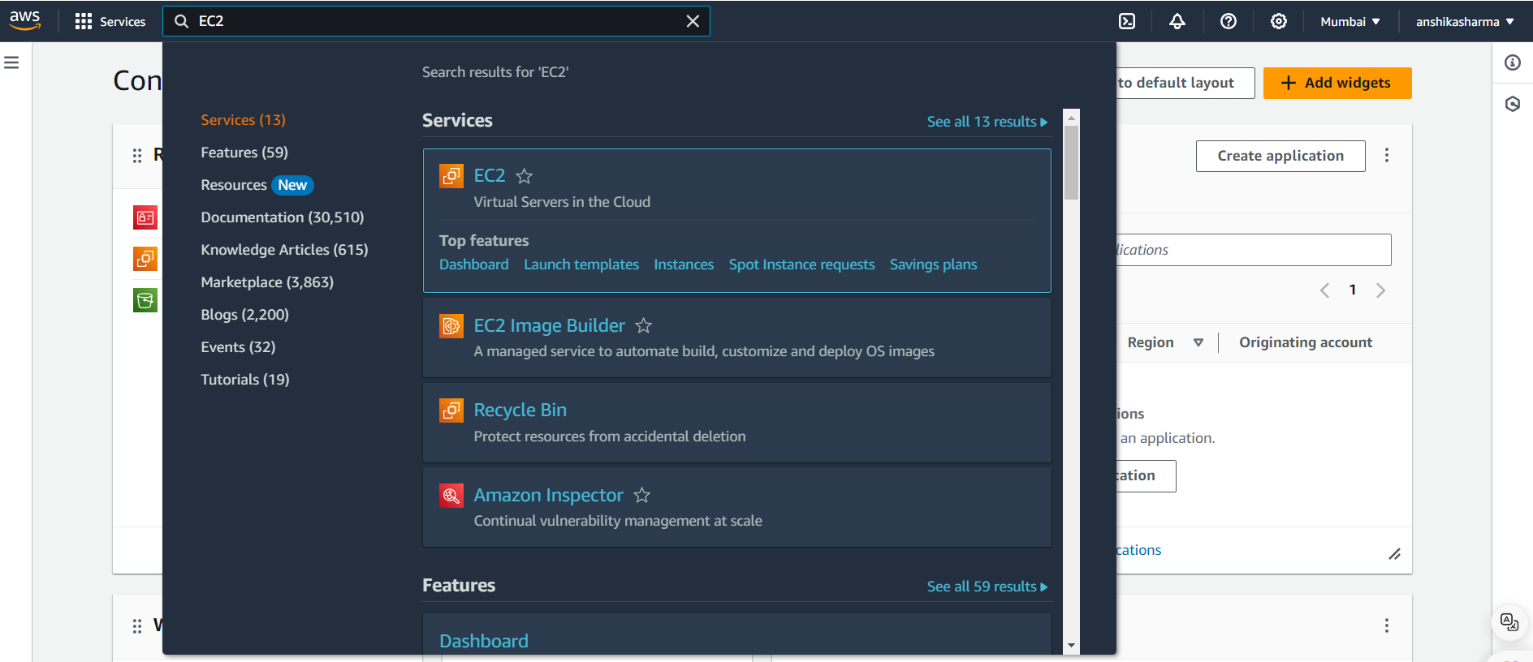

2. Click on "Launch Instance".

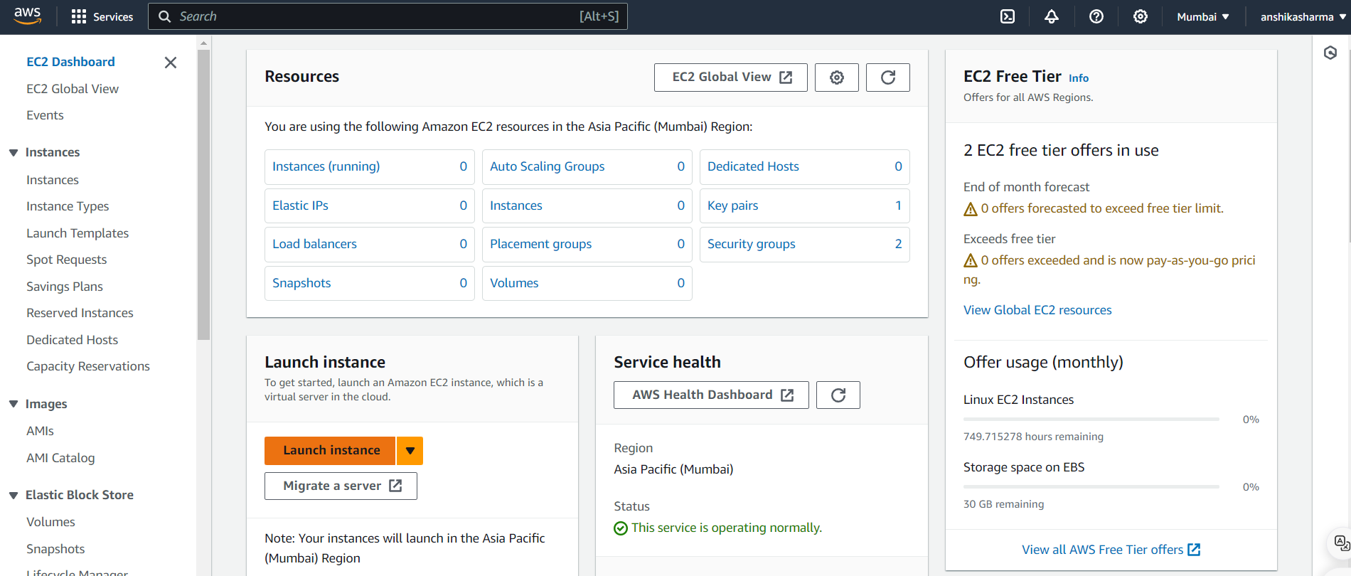

3.Choose an Amazon Machine Image (AMI): Select a Windows AMI. 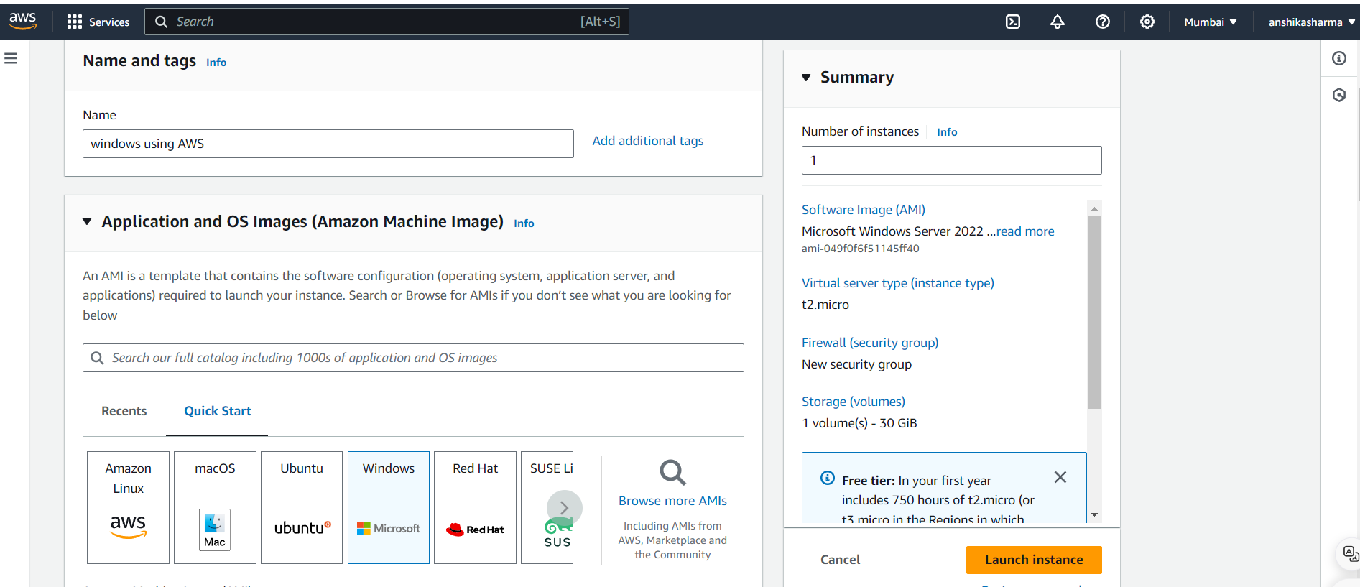

4. Review and Launch: • Review your settings and click "Launch". • Select an existing key pair or create a new key pair. Download the key pair file (.pem), as you will need it to access your instance. 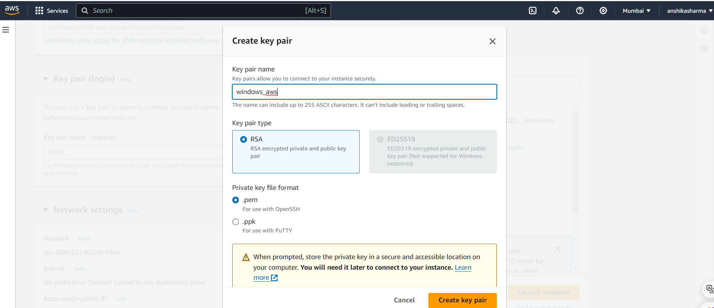

5. The instance has been launched sucessfully.

6. Connect to Your Instance:

After the instance status changes to "running", select the instance.

• Click on "Connect ".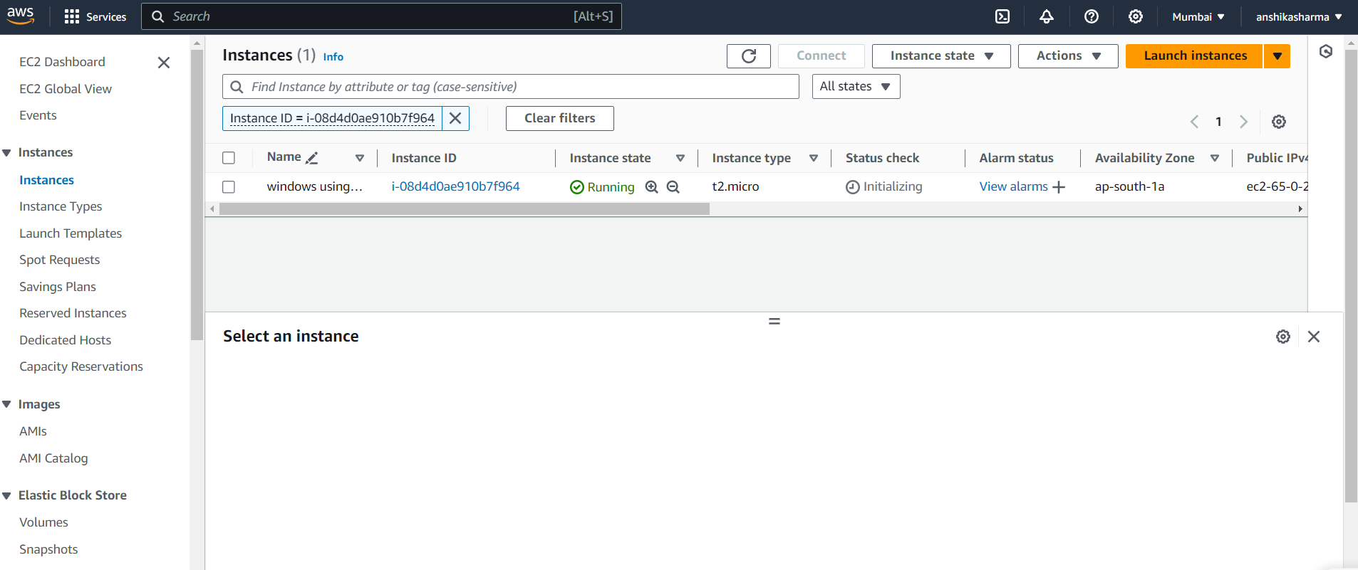 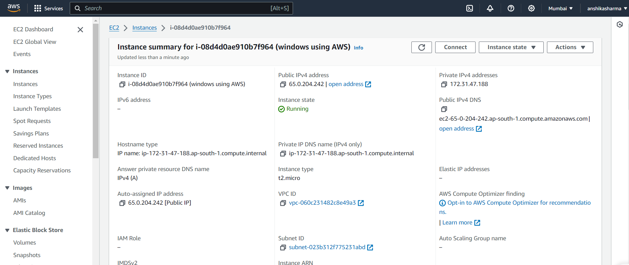

7.Click on “RDP client”.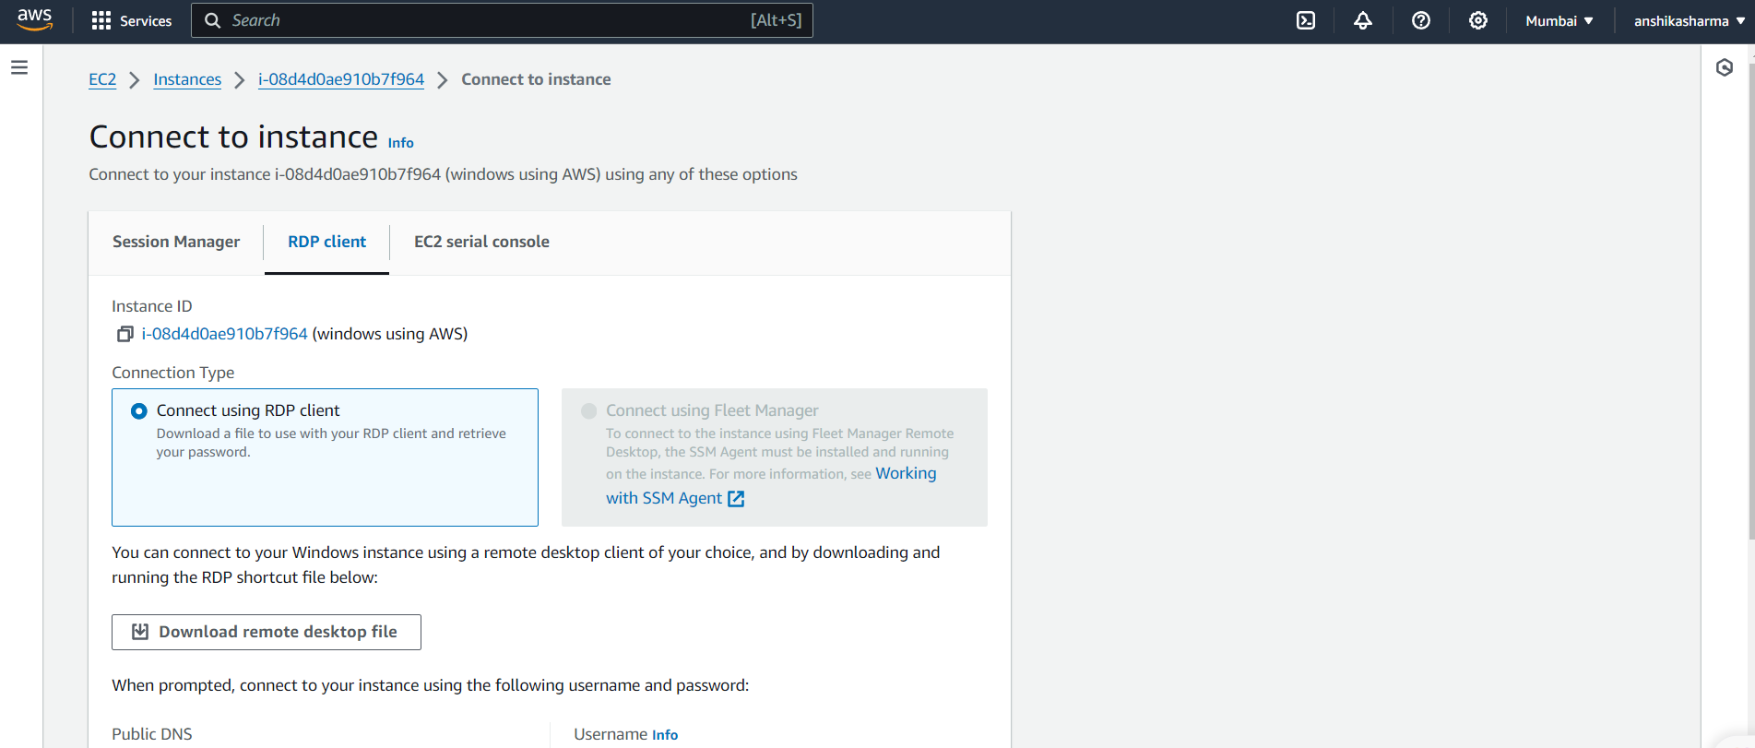

8. Download the Remote Desktop File and get the default password by clicking "Get Password" (you'll need the key pair file for decryption). 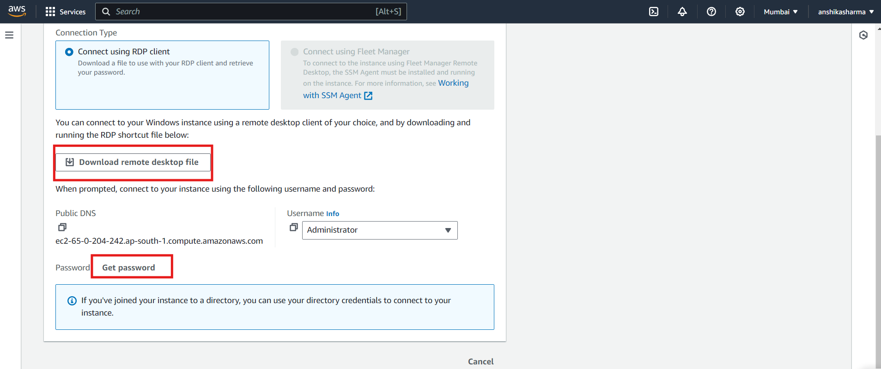 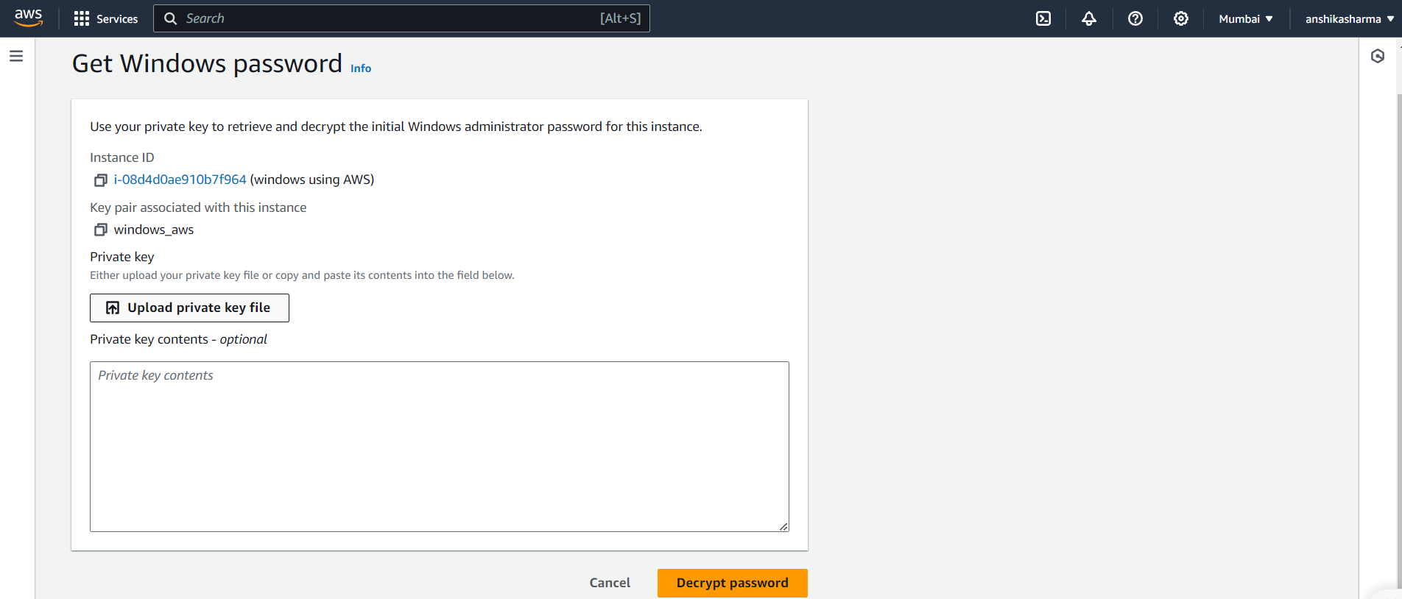 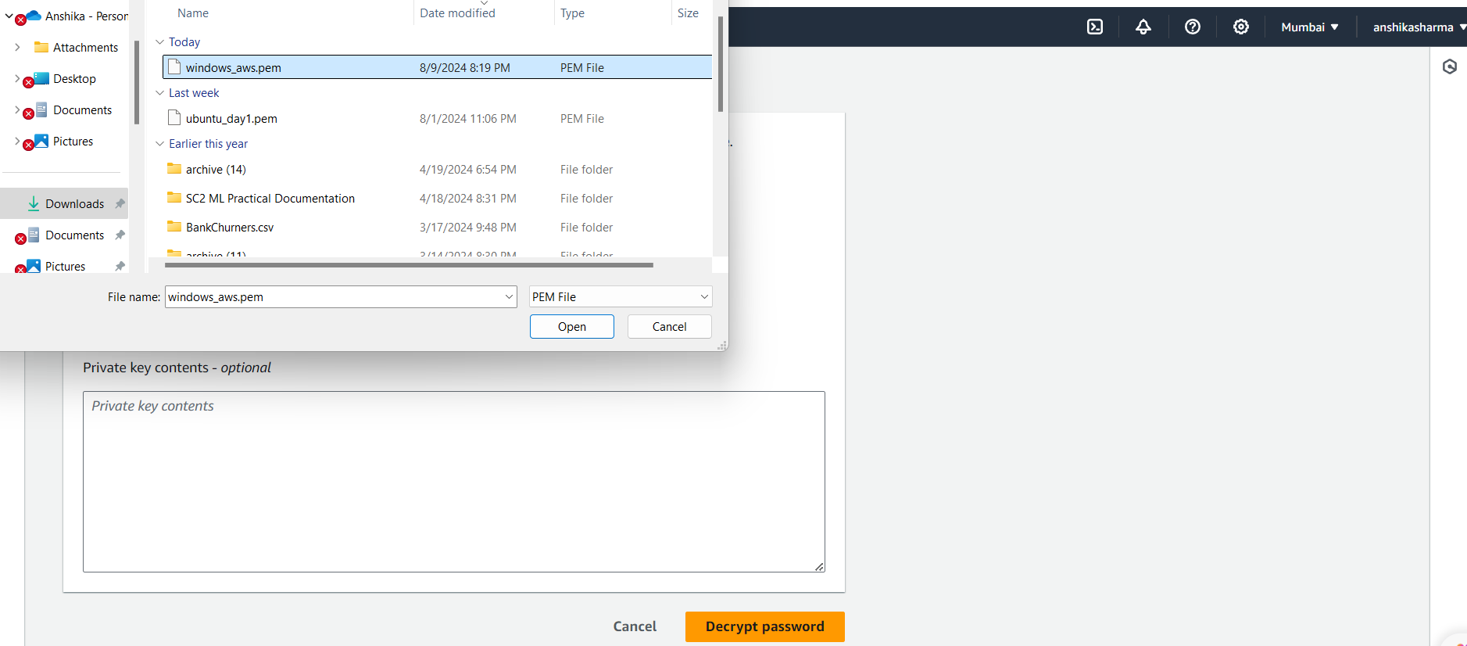 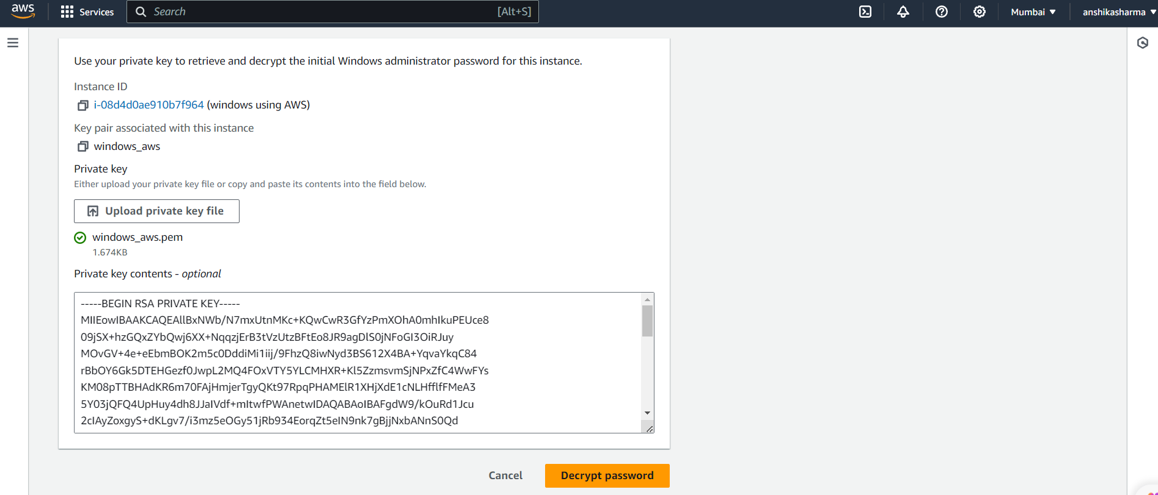 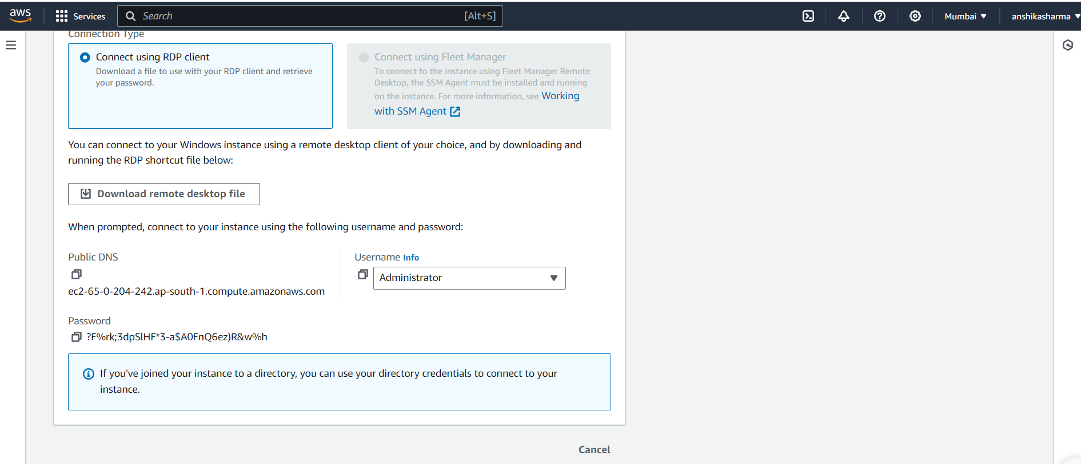 9. Open the downloaded Remote Desktop File and enter the administrator username and decrypted password to connect to your Windows instance. 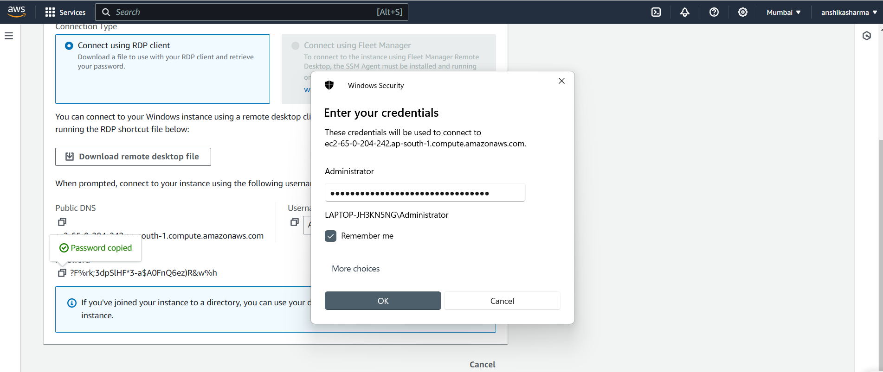

Ques 2:

For ubuntu:

1. Search for EC2 and Click on it.

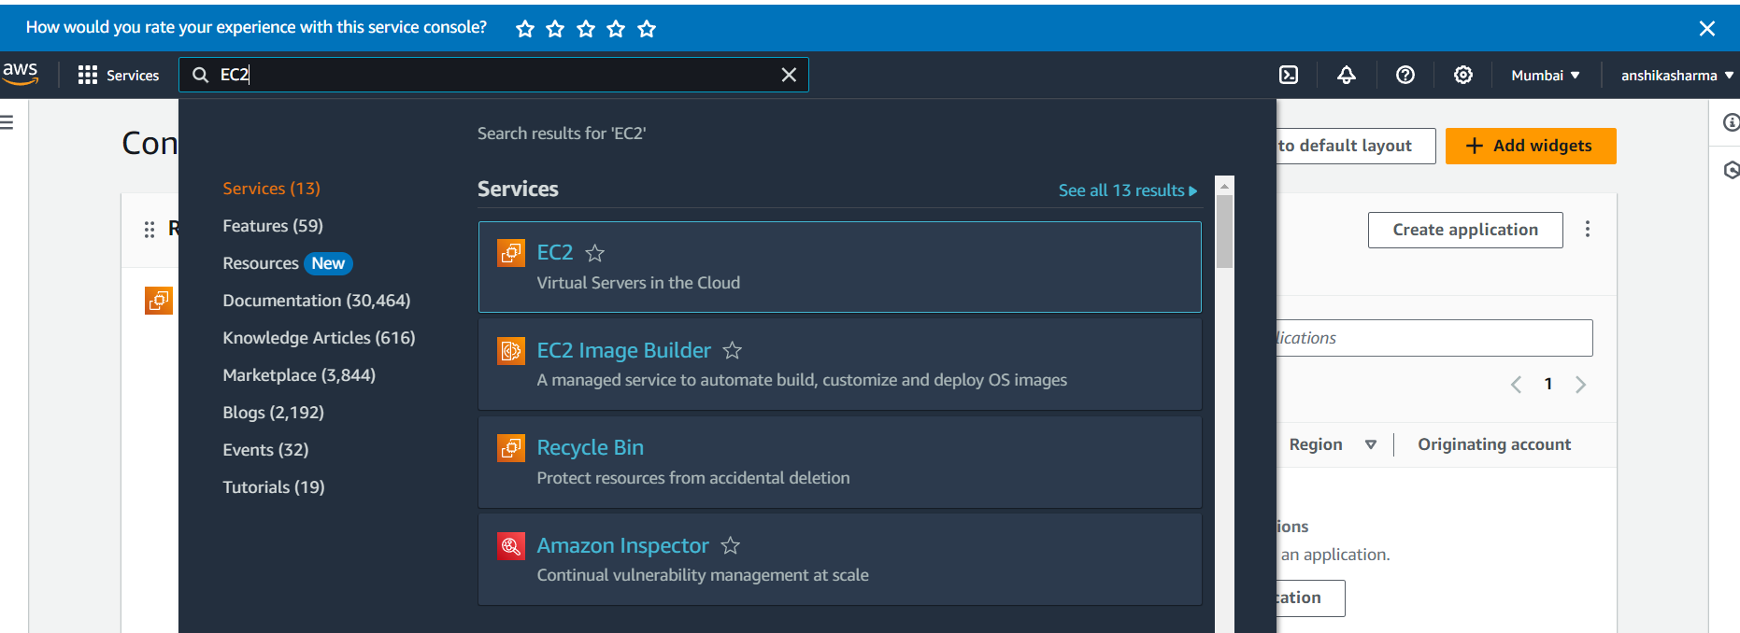

2. Select the Launch Instance in the EC2 dashboard.

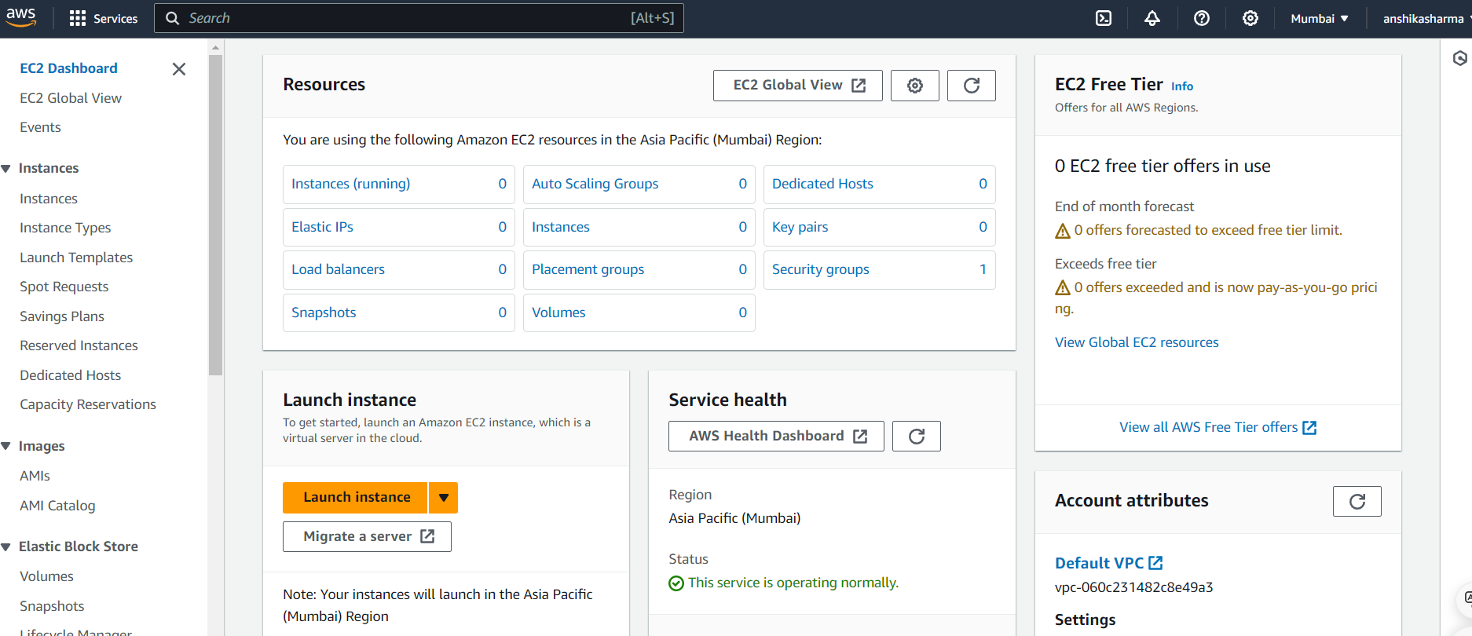

3. Name instance as “CC_Pract_1” and Choose an Amazon Machine Image (AMI)

Select an Ubuntu AMI. Common choices include "Ubuntu Server 20.04 LTS" or "Ubuntu Server 18.04 LTS".

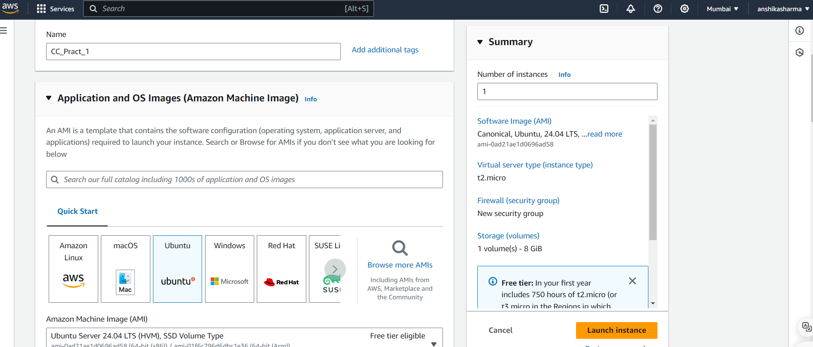

4. Give the new pair key as “ubuntu_day_1” and click on Create new pair key.

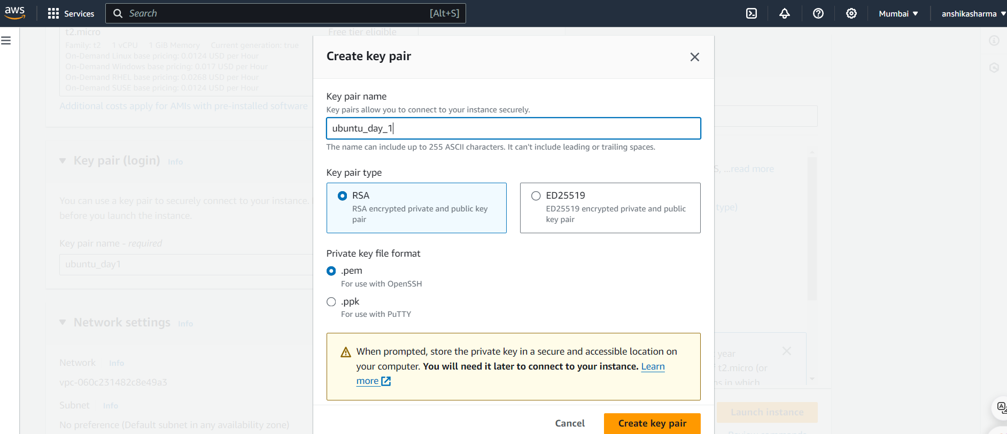

5.After clicking on launch instance, the instance gets launched successfully.

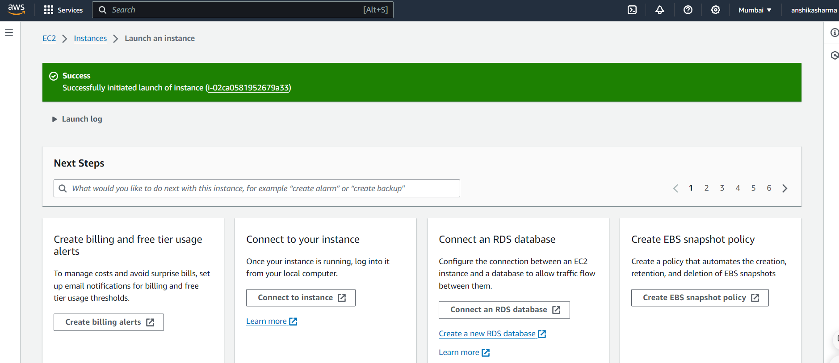

6. Instance “CC_Pract_1” is successfully created.

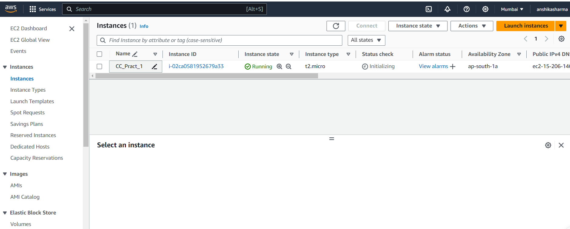

7. Click on connect and the Instance is launched.

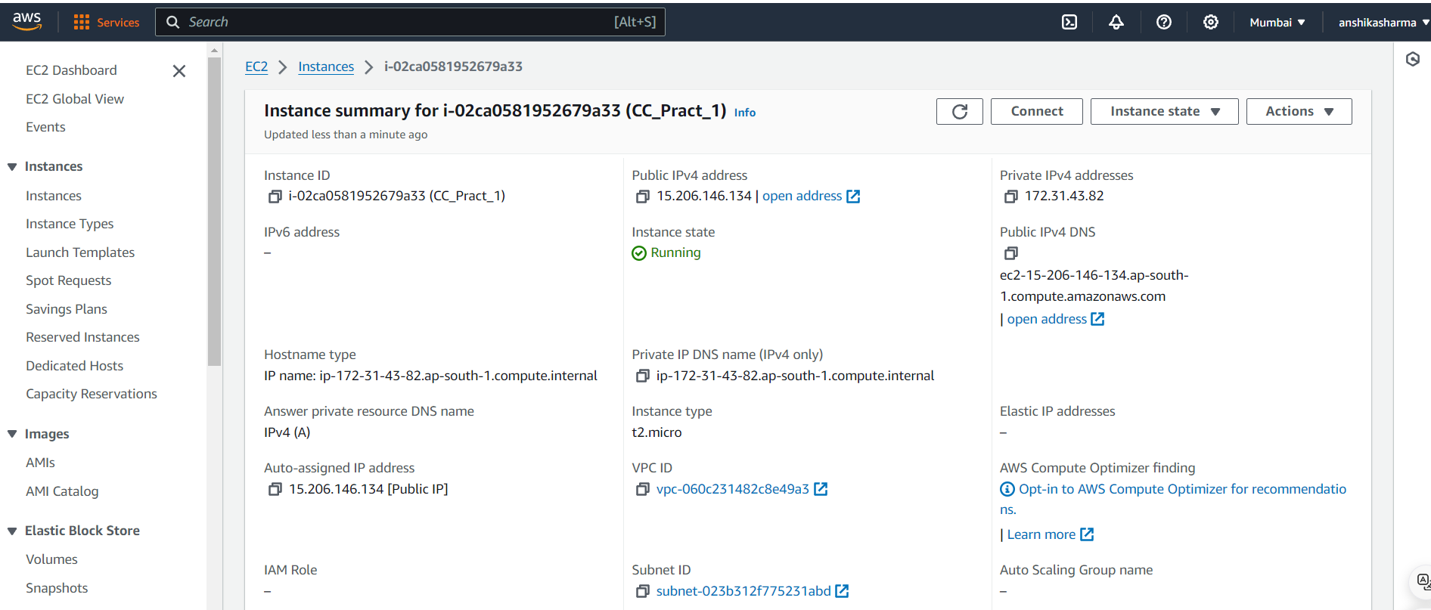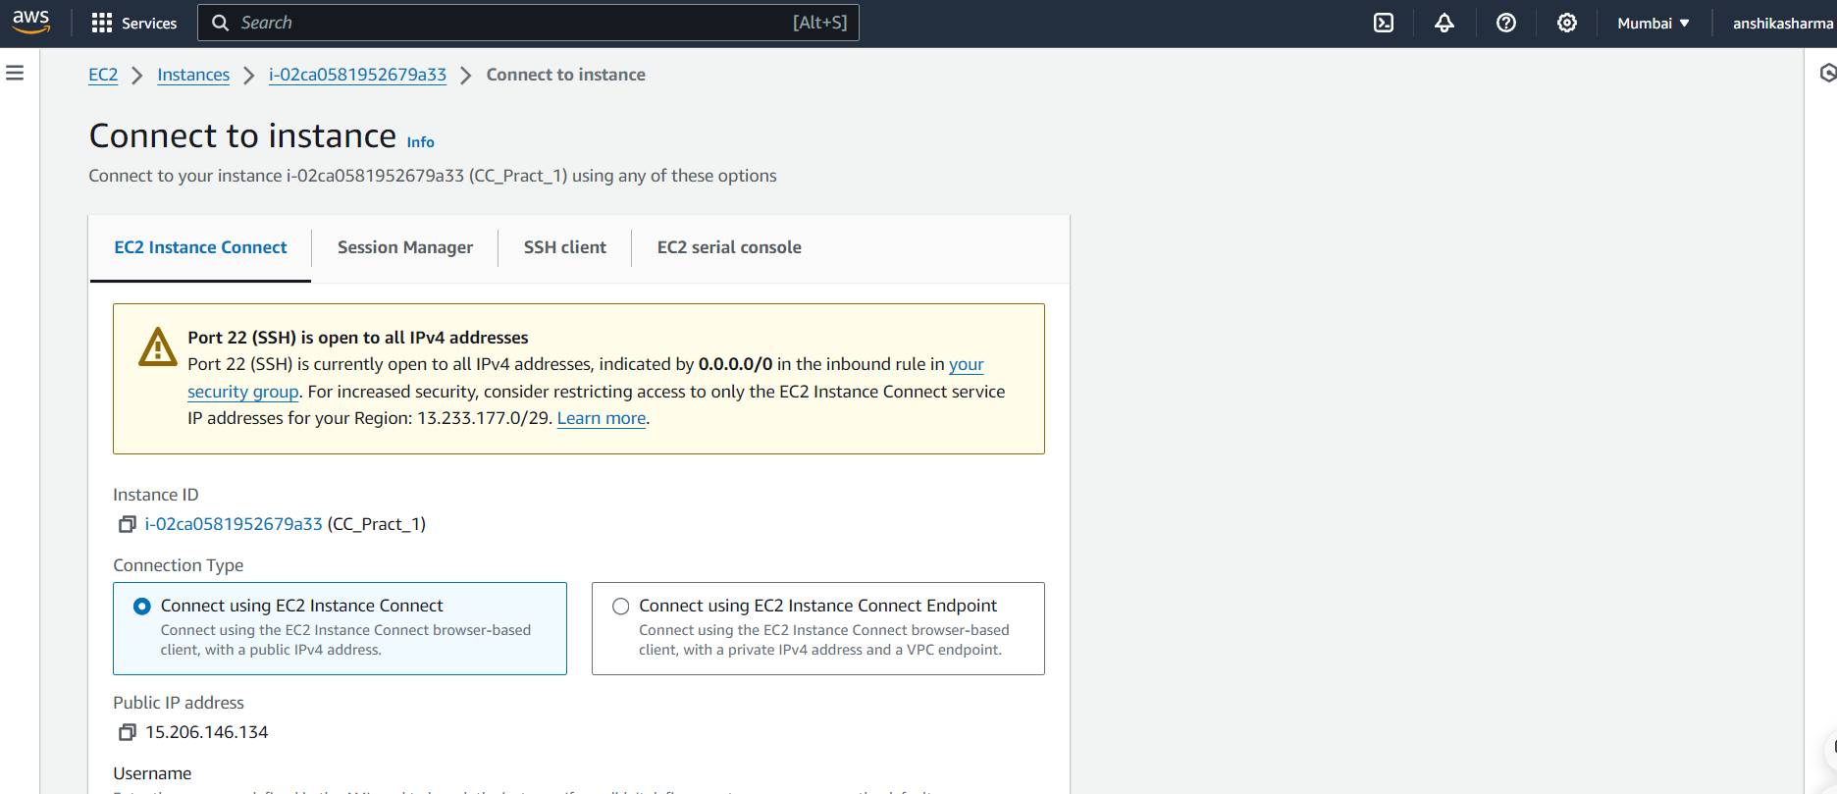

8. Enter the basic ubuntu commands to run.